A
MAJOR PROJECT REPORT
ON
HEART DISEASE PREDICTION USING EFFECTIVE MACHINE LEARNING TECHNIQUES
A project report submitted to the
Jawaharlal Nehru Technological University
In partial fulfillment for the award
Bachelor of Technology
In
COMPUTER SCIENCE AND ENGINEERING
Submitted by
M. Vinay Kumar | : | 16RJ1A05C8
M. Anjanejulu Raju | : | 16RJ1A05F0
M. Lokanand | : | 16RJ1A05F3

Under the Guidance of
Mr. N. Pavan
Assistant Professor

Department of CSE

MALLA REDDY INSTITUTE OF TECHNOLOGY
(Affiliated to JNTU, Hyderabad | Approved by AICTE, New Delhi)
Accredited by NBA, Certificated by ISO 9001:2015
Maisammaguda, Dhullapally, Via: Kompally, Hyderabad - 500100
2016 - 2020



MALLA REDDY INSTITUTE OF TECHNOLOGY
(Sponsored by Malla Reddy Educational Society)
Accredited by NBA
Certificated by ISO 9001:2015
Approved by AICTE & Affiliated to JNTU, Hyderabad
Maisammaguda, Dhullapally Post, (Via: Kompally), Secunderabad - 500100.

CERTIFICATE

This is to certify that this project work entitled “HEART DISEASE PREDICTION USING EFFECTIVE MACHINE LEARNING TECHNIQUES” is a Bonafide work carried out by M.Vinay kumar bearing Hall Ticket Number: 16RJ1A05C8, M.Anjaneyulu Raju bearing Hall Ticket Number: 16RJ1A05F0, M.Lokanand bearing Hall Ticket Number: 16RJ1A05F3 of COMPUTER SCIENCE AND ENGINEERING DEPARTMENT at MALLA REDDY INSTITUTE OF TECHNOLOGY and submitted to JNT UNIVERSITY, HYDERABAD in the partial fulfillment of the requirements for the award of BACHELOR OF TECHNOLOGY.

Project Guide | Project Coordinator | Head of the Department
Mr. N. Pavan | Dr. Sateesh Nagavarapu | Dr. M. Kalimuthu
Asst.Professor | Associate Professor | Associate Professor
Department of CSE | Department of CSE | Department of CSE

External Examiner
ACKNOWLEDGEMENTS

We are happy to express our deep sense of gratitude to the Principal of the college Dr.K.Srinivasa Rao , Professor, Malla Reddy Institute of Technology for having provided us the adequate facilities to pursue our project.
We would like to thank Dr. M. Kalimuthu, Associate Professor and Head, Department of Computer Science and Engineering, Malla Reddy Institute of Technology, for having provided the freedom to use all the facilities available in the department, especially the laboratories and library.
We also grateful to our project coordinator, Dr. Sateesh Nagavarapu, Associate professor, Department of Computer Science and Engineering, Malla Reddy Institute of Technology, for extending his support and assisting us throughout our project work.
We very grateful to our project guide, Mr. N. Pavan, Assistant Professor, Department of Computer Science and Engineering, Malla Reddy Institute of Technology, for his extensive patience and guidance throughout our project work.
We sincerely thank all the Teaching and Non-teaching staff of the department of Computer Science and Engineering, also like to thank our Classmates for their timely suggestions, healthy criticism and motivation during the course of our project work. We thank our parents who were the backbone behind our deeds.
Finally, we express our immense gratitude with pleasure to all individuals who have either directly or indirectly contributed to our need at right time for the development and success of our project

DECLARATION

We hereby declare that the project entitled “HEART DISEASE PREDICTION USING EFFECTIVE MACHINE LEARNING TECHNIQUES” submitted to Malla Reddy Institute Of Technology, affiliated to Jawaharlal Nehru Technological University Hyderabad (JNTUH) for the award of the degree of BACHELOR OF TECHNOLOGY in COMPUTER SCIENCE AND ENGINEERING is a result of work done by us. It is further declared that the project report or any part of it has not been previously submitted to any university or institute for the award of degree.

M. Vinay Kumar | : | 16RJ1A05C8
M. Anjanejulu Raju | : | 16RJ1A05F0
M. Lokanand | : | 16RJ1A05F3

ABSTRACT
In the medical field, the diagnosis of heart disease is the most difficult task. The diagnosis of heart disease is difficult as a decision relied on grouping of large clinical and pathological data. Due to this complication, the interest increased in a significant amount between the researchers and clinical professionals about the efficient and accurate heart disease prediction. In case of heart disease, the correct diagnosis in early stage is important as time is the very important factor. Heart disease is the principal source of deaths widespread, and the prediction of Heart Disease is significant at an untimely phase. Machine learning in recent years has been the evolving, reliable and supporting tools in medical domain and has provided the greatest support for predicting disease with correct case of training and testing. The main idea behind this work is to study diverse prediction models for the heart disease and selecting important heart disease feature using genetic algorithm. The optimized prediction models using genetic algorithm performance is better than traditional prediction models. The performances of the different prediction models retested with different heart disease data sets and validated with real-time data sets.

INDEX
LIST OF FIGURES vii
LIST OF SCREEN SHOTS viii
1. INTRODUCTION 1
1.1 Introduction 1
1.2 Problem Statement 1
1.3 Objective 1
1.4 Existing System 2
1.5 Proposed System 2
1.6 Introduction To Machine Learning 2
1.6.1 Introduction 2
1.6.2 Classification of Machine Learning 2
1.6.3 Categorizing on the basis of required Output 3
1.6.4 A Machine Learning Framework 4
2. SYSTEM ANALYSIS 17
2.1 Methodology 17
2.2 Data collection 17
2.3 Software Development Life Cycle (Spiral Model) 17
2.4 Data Mining 24
2.5 Algorithm implemented 28
2.6 System Architecture 35
3. FEASIBILITY STUDY 37
3.1 Economical Feasibility 37
3.2 Technical Feasibility 37
3.3 Social Feasibility 37
4. REQUIREMENT SPECIFICATIONS 39
4.1 Hardware Requirements 39
4.2 Software Requirements 39
4.2.1 Introduction to Python 39
4.2.2 Modules used 41
4.2.3 Anaconda 42
5. SYSTEM DESIGN 44
5.1 Introduction 44
5.2 Data Flow Diagram 44
5.3 UML Diagrams 45
5.3.1 Use Case diagram 46
5.3.2 Class Diagram 47
5.3.3 Sequence Diagram 48
5.3.4 Activity Diagram 49
7. SYSTEM TEST 51
7.1 Introduction 51
7.2 Test strategy and approach 53
8. OUTPUT SCREENS 54
9. CONCLUSION 56
10. BIBLIOGRAPHY 57
11. REFRENCES 58

LIST OF FIGURES
1.1 cross validation | 16
2.1 SDLC(Spiral model) | 17
2.2 Requirements Gathering stage | 18
2.3 Analysis Stage | 20
2.4 Designing Stage | 21
2.5 Development (Coding) Stage | 22
2.6 Integration & Test Stage | 23
2.7 Installation & Acceptance Test | 24
2.8 knn example-1 | 28
2.9 knn example-2 | 29
2.10 decision tree example | 30
2.11 GNB | 32
2.12 Random forest | 33
2.13 Random forest example | 34
2.14 system architecture | 35
5.1 Data flow diagram | 44
5.2 usecase diagram | 46
5.3 Class Diagram | 47
5.4 Sequence Diagram | 48
5.5 Activity Diagram | 49

LIST OF SCREEN SHOTS

9.1 Dataset | 54
9.2 Data visualization | 54
9.3 Data preprocessing | 55
9.4 Training and testing | 55
9.5 predicting | 55

1. INTRODUCTION

1.1 Introduction
The highest mortality of both India and abroad is mainly because of heart disease. According to World Health Organization (WHO), heart related diseases are responsible for the taking 17.7 million lives every year, 31% of all global deaths. Hence, this is vital time to check this death rate by identifying the disease correctly in the initial stage.
Preventing heart disease is important. Good systems for predicting heart disease can improve the entire research and prevention process, making sure that more people can live healthy lives.
The main topic is prediction using machine learning technics. Machine learning is widely used now a days in many business applications like e-commerce and many more. Prediction is one of area where this machine learning used, our topic is about prediction of heart disease by processing patient’s dataset and a data of patients to whom we need to predict the chance of occurrence of a heart disease.

1.2 Problem Statement
We need to reach a doctor to know about our heart condition and it takes a lot of time and money. So, developing a model which can predict occurrence of heart disease can help us very much and also reduce the cost and time.

1.3 Objective
To develop a model using machine learning which can predict chance of a person to get heart disease and with more accuracy.

1.4 Existing System
Diagnosis of the condition solely depends upon the Doctor's intuition.
Disadvantage
- Detection is not possible at an earlier stage
- In this existing system is time consuming and costly

1.5 Proposed System
In proposed system we don’t depend upon doctor but we use algorithms to predict heart disease through machine learning.
We use algorithms like K- nearest neighbor, Naïve Bayes, Random forest and decision tree to increase accuracy of result.
Advantage
- Very less time taking and accurate result.
- Detection is possible at an earlier stage.

1.6 Introduction To Machine Learning

1.6.1 Introduction
Machine learning is a subfield of artificial intelligence (AI). The goal of machine learning generally is to understand the structure of data and fit that data into models that can be understood and utilized by people.

1.6.2 Classification of Machine Learning
Supervised learning
In supervised learning, the computer is provided with example inputs that are labeled with their desired outputs. The purpose of this method is for the algorithm to be able to “learn” by comparing its actual output with the “taught” outputs to find errors, and modify the model accordingly. Supervised learning therefore uses patterns to predict label values on additional unlabeled data.
For example, with supervised learning, an algorithm may be fed data with images of sharks labeled as fish and images of oceans labeled as water. By being trained on this data, the supervised learning algorithm should be able to later identify unlabeled shark images as fish and unlabeled ocean images as water.
A common use case of supervised learning is to use historical data to predict statistically likely future events. It may use historical stock market information to anticipate upcoming fluctuations, or be employed to filter out spam emails. In supervised learning, tagged photos of dogs can be used as input data to classify untagged photos of dogs.
Unsupervised learning
In unsupervised learning, data is unlabeled, so the learning algorithm is left to find commonalities among its input data. As unlabeled data are more abundant than labeled data, machine learning methods that facilitate unsupervised learning are particularly valuable.
The goal of unsupervised learning may be as straightforward as discovering hidden patterns within a dataset, but it may also have a goal of feature learning, which allows the computational machine to automatically discover the representations that are needed to classify raw data.
Unsupervised learning is commonly used for transactional data. You may have a large dataset of customers and their purchases, but as a human you will likely not be able to make sense of what similar attributes can be drawn from customer profiles and their types of purchases. With this data fed into an unsupervised learning algorithm, it may be determined that women of a certain age range who buy unscented soaps are likely to be pregnant, and therefore a marketing campaign related to pregnancy and baby products can be targeted to this audience in order to increase their number of purchases.
Without being told a “correct” answer, unsupervised learning methods can look at complex data that is more expansive and seemingly unrelated in order to organize it in potentially meaningful ways. Unsupervised learning is often used for anomaly detection including for fraudulent credit card purchases, and recommender systems that recommend what products to buy next. In unsupervised learning, untagged photos of dogs can be used as input data for the algorithm to find likenesses and classify dog photos together.

1.6.3 Categorizing on the basis of required Output
Classification
When inputs are divided into two or more classes, and the learner must produce a model that assigns unseen inputs to one or more (multi-label classification) of these classes. This is typically tackled in a supervised way. Spam filtering is an example of classification, where the inputs are email (or other) messages and the classes are “spam” and “not spam”.
Regression
Which is also a supervised problem, A case when the outputs are continuous rather than discrete.
Clustering
When a set of inputs is to be divided into groups. Unlike in classification, the groups are not known beforehand, making this typically an unsupervised task.

1.6.4 A Machine Learning Framework
The competition solution workflow goes through seven stages described as
- Question or problem definition.
- Acquire training and testing data.
- Wrangle, prepare, and cleanse the data.
- Analyze, identify patterns, and explore the data.
- Model, predict and solve the problem.
- Visualize, report, and present the problem solving steps and final solution.
- Supply or submit the results.
The workflow indicates general sequence of how each stage may follow the other. However there are use cases with exceptions.
- We may combine multiple workflow stages. We may analyze by visualizing data.
- Perform a stage earlier than indicated. We may analyze data before and after wrangling.
- Perform a stage multiple times in our workflow. Visualize stage may be used multiple times.
- Drop a stage altogether. We may not need supply stage to productize or service enable our dataset for a competition.
- Define the Problem: If data science, big data, machine learning, predictive analytics, business intelligence, or any other buzzword is the solution, then what is the problem? As the saying goes, don't put the cart before the horse. Problems before requirements, requirements before solutions, solutions before design, and design before technology. Too often we are quick to jump on the new shiny technology, tool, or algorithm before determining the actual problem we are trying to solve.
- Gather the Data: John Naisbitt wrote in his 1984 (yes, 1984) book Megatrends, we are “drowning in data, yet staving for knowledge." So, chances are, the dataset(s) already exist somewhere, in some format. It may be external or internal, structured or unstructured, static or streamed, objective or subjective, etc. As the saying goes, you don't have to reinvent the wheel, you just have to know where to find it. In the next step, we will worry about transforming "dirty data" to "clean data."
- Prepare Data for Consumption: This step is often referred to as data wrangling, a required process to turn “wild” data into “manageable” data. Data wrangling includes implementing data architectures for storage and processing, developing data governance standards for quality and control, data extraction (i.e. ETL and web scraping), and data cleaning to identify aberrant, missing, or outlier data points.
- Perform Exploratory Analysis: Anybody who has ever worked with data knows garbage-in, garbage-out (GIGO). Therefore, it is important to deploy descriptive and graphical statistics to look for potential problems, patterns, classifications, correlations and comparisons in the dataset. In addition, data categorization (i.e. qualitative vs quantitative) is also important to understand and select the correct hypothesis test or data model.
- Model Data: Like descriptive and inferential statistics, data modeling can either summarize the data or predict future outcomes. Your dataset and expected results, will determine the algorithms available for use. It's important to remember, algorithms are tools and not magical wands or silver bullets. You must still be the master craft (wo)man that knows how-to select the right tool for the job. An analogy would be asking someone to hand you a Philip screwdriver, and they hand you a flathead screwdriver or worst a hammer. At best, it shows a complete lack of understanding. At worst, it makes completing the project impossible. The same is true in data modeling. The wrong model can lead to poor performance at best and the wrong conclusion (that’s used as actionable intelligence) at worst.
- Validate and Implement Data Model: After you've trained your model based on a subset of your data, it's time to test your model. This helps ensure you haven't over fit your model or made it so specific to the selected subset, that it does not accurately fit another subset from the same dataset. In this step we determine if our model over fit, generalize, or under fit our dataset.
- Optimize and Strategize: This is the "bionic man" step, where you iterate back through the process to make it better...stronger...faster than it was before. As a machine learning engineer or data scientist, your strategy should be to outsource developer operations and application plumbing, so you have more time to focus on recommendations and design. Once you're able to package your ideas, this becomes your “currency exchange" rate.

Question and problem definition
Define the problem to solve or questions to ask while providing the datasets for training your data science model and testing the model results against a test dataset. The question or problem definition for competition is described
We may also want to develop some early understanding about the domain of our problem.
Classifying: We may want to classify or categorize our samples. We may also want to understand the implications or correlation of different classes with our solution goal.
Correlating: One can approach the problem based on available features within the training dataset. Which features within the dataset contribute significantly to our solution goal? Statistically speaking is there a correlation among a feature and solution goal? As the feature values change does the solution state change as well, and vice-versa? This can be tested both for numerical and categorical features in the given dataset. We may also want to determine correlation among features other than survival for subsequent goals and workflow stages. Correlating certain features may help in creating, completing, or correcting features.
Converting: For modeling stage, one needs to prepare the data. Depending on the choice of model algorithm one may require all features to be converted to numerical equivalent values. So, for instance converting text categorical values to numeric values.
Completing: Data preparation may also require to estimate any missing values within a feature. Model algorithms may work best when there are no missing values.
Correcting: We may also analyze the given training dataset for errors or possibly inaccurate values within features and try to correct these values or exclude the samples containing the errors. One way to do this is to detect any outliers among our samples or features. We may also completely discard a feature if it is not contributing to the analysis or may significantly skew the results.
Creating: Can we create new features based on an existing feature or a set of features, such that the new feature follows the correlation, conversion, completion of goals?
Charting: How to select the right visualization plots and charts depending on the nature of the data and the solution goals?
Corrections: Corrections did after working on data
Best practices
- Performing feature correlation analysis early in the project.
- Using multiple plots instead of overlays for readability.

Acquire data
The Python Pandas package helps us work with our datasets. We start by acquiring the training and testing datasets into Pandas Data-Frame. We also combine these datasets to run certain operations on both datasets together.

Analyze by describing data
Pandas also help describing the datasets answering following questions early in our project.

Import Libraries
The following code is written in Python 3.x. Libraries provide pre-written functionality to perform necessary tasks. The idea is why write ten lines of code, when you can write one line.
Load Data Modeling Libraries
We will use the popular scikit-learn library to develop our machine learning algorithms. In sklearn, algorithms are called Estimators and implemented in their own classes.
For data visualization, we will use the matplotlib and seaborn library. Below are common classes to load.
Meet and Greet Data
This is the meet and greet step. Get to know your data by first name and learn a little bit about it. What does it look like (data type and values), what makes it tick (independent/feature variables(s)), what are its goals in life (dependent/target variable(s)).
To begin this step, we first import our data. Next we use the info() and sample() function, to get a quick and dirty overview of variable data types (i.e. qualitative vs quantitative)
The add colunm name which is dependent variable is our outcome or dependent variable. All other variables are potential predictor or independent variables. It's important to note, more predictor variables do not make a better model, but the right variables.

Which features are categorical?
These values classify the samples into sets of similar samples. Within categorical features are the values nominal, ordinal, ratio, or interval based? Among other things this helps us select the appropriate plots for visualization.

Which features are numerical?
Which features are numerical? These values change from sample to sample. Within numerical features are the values discrete, continuous or time series based? Among other things this helps us select the appropriate plots for visualization.

Which features are mixed data types?
Numeric and Alphanumeric data within the same feature.

Which features may contain errors or typos?
This is harder to review for a large dataset, however reviewing a few samples from a smaller dataset may just tell us outright, which features may require correcting.
- Name feature may contain errors or typos as there are several ways used to describe a name including titles, round brackets, and quotes used for alternative or short names.

Which features contain blank, null or empty values?
These will require correcting.
- Some features contain a number of null values in that order for the training dataset.
- Some features are incomplete in case of test dataset.

What are the data types for various features?
Information will provide dtypes for different features , available data types are float, int, object and bool.

What is the distribution of numerical feature values across the samples?
This helps us determine, among other early insights, how representative is the training dataset of the actual problem domain. And the available numerical features.

What is the distribution of categorical features?
This helps us determine, among other early insights, how representative is the training dataset of the actual problem domain. And the available categorical features.

Wrangle data
- We have collected several assumptions and decisions regarding our datasets and solution requirements. So far we did not have to change a single feature or value to arrive at these. Let us now execute our decisions and assumptions for correcting, creating, and completing goals.
Developer Documentation:
- pandas.DataFrame
- pandas.DataFrame.info
- pandas.DataFrame.describe
- Indexing and Selecting Data
- pandas.isnull
- pandas.DataFrame.sum
- pandas.DataFrame.mode
- pandas.DataFrame.copy
- pandas.DataFrame.fillna
- pandas.DataFrame.drop
- pandas.Series.value_counts
- pandas.DataFrame.loc

Correlating
We want to know how well does each feature correlate with Survival. We want to do this early in our project and match these quick correlations with modeled correlations later in the project.

Completing
There are null values or missing data in the features. Missing values can be bad, because some algorithms don't know how-to handle null values and will fail. While others, like decision trees, can handle null values. Thus, it's important to fix before we start modeling, because we will compare and contrast several models. There are two common methods, either delete the record or populate the missing value using a reasonable input. It is not recommended to delete the record, especially a large percentage of records, unless it truly represents an incomplete record. Instead, it's best to impute missing values. A basic methodology for qualitative data is imputing using mode. A basic methodology for quantitative data is imputing using mean, median, or mean and randomized standard deviation.
There are more complex methodologies, however before deploying; it should be compared to the base model to determine if complexity truly adds value. For this dataset,. Subsequent model iterations may modify this decision to determine if it improves the model’s accuracy.
- A simple way is to generate random numbers between mean and standard deviation.
- More accurate way of guessing missing values is to use other correlated features. Combine methods 1 and 2. So instead of guessing age values based on median, use random numbers between mean and standard deviation, based on sets of categorical and numerical features

Correcting
Reviewing the data, there does not appear to be any aberrant or non-acceptable data inputs. In addition, we see we may have potential outliers in features. However, since they are reasonable values, we will wait until after we complete our exploratory analysis to determine if we should include or exclude from the dataset. However, we want to use caution when we modify data from its original value, because it may be necessary to create an accurate model.
- This is a good starting goal to execute. By dropping features we are dealing with fewer data points. Speeds up our notebook and eases the analysis.
- Note that where applicable we perform operations on both training and testing datasets together to stay consistent.
- Feature may be dropped from our analysis as it contains high ratio of duplicates and there may not be a correlation between Features.
- Feature may be dropped as it is highly incomplete or contains many null values both in training and test dataset.
- FeatureID may be dropped from training dataset as .
- Some features are relatively non-standard, may not contribute directly to dependent feature, so maybe dropped.

Creating
Feature engineering is when we use existing features to create new features to determine if they provide new signals to predict our outcome. For this dataset, we will create a feature to determine if it played a role in .

Classifying
We may also add to our assumptions based on the problem description noted earlier.

Convert Formats
We will convert categorical data to dummy variables for mathematical analysis. There are multiple ways to encode categorical variables; we will use the sklearn and pandas functions.
In this step, we will also define our x (independent/features/explanatory/predictor/etc.) and y (dependent/target/outcome/response/etc.) variables for data modeling.
Developer Documentation
- Categorical Encoding
- Sklearn LabelEncoder
- Sklearn OneHotEncoder
- Pandas Categorical dtype
- pandas.get_dummies
There are no date or currency formats, but data type formats. Our categorical data imported as objects, which makes it difficult for mathematical calculations. For this dataset, we will convert object data types to categorical dummy variables.

Analyze by pivoting features
To confirm some of our observations and assumptions, we can quickly analyze our feature correlations by pivoting features against each other. We can only do so at this stage for features which do not have any empty values. It also makes sense doing so only for features which are categorical, ordinal or discrete type.
Perform Exploratory Analysis with Statistics
Now that our data is cleaned, we will explore our data with descriptive and graphical statistics to describe and summarize our variables. In this stage, you will find yourself classifying features and determining their correlation with the target variable and each other.
Now we can continue confirming some of our assumptions using visualizations for analyzing the data.

Pearson Correlation Heat map
let us generate some correlation plots of the features to see how related one feature is to the next. To do so, we will utilize the Seaborn plotting package which allows us to plot heatmaps very conveniently as follows

Take away from the Plots
One thing that that the Pearson Correlation plot can tell us is that there are not too many features strongly correlated with one another. This is good from a point of view of feeding these features into your learning model because this means that there isn't much redundant or superfluous data in our training set and we are happy that each feature carries with it some unique information. Here are two most correlated features .

Pairplots
Finally let us generate some pairplots to observe the distribution of data from one feature to the other. Once again we use Seaborn to help us.

Correlating numerical features
Let us start by understanding correlations between numerical features and our solution goal ?
A histogram chart is useful for analyzing continuous numerical variables like Age where banding or ranges will help identify useful patterns. The histogram can indicate distribution of samples using automatically defined bins or equally ranged bands. This helps us answer questions relating to specific bands
Note that x-axis in histogram visualizations represents the count of samples or passengers.

Decisions:
This simple analysis confirms our assumptions as decisions for subsequent workflow stages.

Correlating numerical and ordinal features
We can combine multiple features for identifying correlations using a single plot. This can be done with numerical and categorical features which have numeric values.

Correlating categorical features
Now we can correlate categorical features with our solution goal..

Correlating categorical and numerical features
We may also want to correlate categorical features (with non-numeric values) and numeric features

Split Training and Testing Data:
As mentioned previously, the test file provided is really validation data for competition submission. So, we will use sklearn function to split the training data in two datasets; 75/25 split. This is important, so we don't over fit our model. Meaning, the algorithm is so specific to a given subset, it cannot accurately generalize another subset, from the same dataset. It's important our algorithm has not seen the subset we will use to test, so it doesn't "cheat" by memorizing the answers. We will use sklearn's train_test_split function. In later sections we will also use sklearn's cross validation functions, that splits our dataset into train and test for data modeling comparison.

Model Data:
Data Science is a multi-disciplinary field between mathematics (i.e. statistics, linear algebra, calculus, etc.), computer science (i.e. programming languages, computer systems, etc.) and business management (i.e. communication, subject-matter knowledge, etc.). Most data scientist comes from one of the three fields, so they tend to lean towards that discipline. However, data science is like a three-legged stool, with no one leg being more important than the other. So, this step will require advanced knowledge in mathematics
Machine Learning (ML), as the name suggest, is teaching the machine how-to think and not what to think. While this topic and big data has been around for decades, it is becoming more popular than ever because the barrier to entry is lower, for businesses and professionals alike. This is both good and bad. It’s good because these algorithms are now accessible to more people that can solve more problems in the real-world
First, you must understand, that the purpose of machine learning is to solve human problems. Machine learning can be categorized as: supervised learning, unsupervised learning, and reinforced learning.
Supervised learning is where you train the model by presenting it a training dataset that includes the correct answer.
Unsupervised learning is where you train the model using a training dataset that does not include the correct answer.
And reinforced learning is a hybrid of the previous two, where the model is not given the correct answer immediately, but later after a sequence of events to reinforce learning.
We are doing supervised machine learning, because we are training our algorithm by presenting it with a set of features and their corresponding target. We then hope to present it a new subset from the same dataset and have similar results in prediction accuracy.
There are many machine learning algorithms, however they can be reduced to four categories: classification, regression, clustering, or dimensionality reduction, depending on your target variable and data modeling goals. We can generalize that a continuous target variable requires a regression algorithm and a discrete target variable requires a classification algorithm. One side note, logistic regression, while it has regression in the name, is really a classification algorithm. We will use cross validation and scoring metrics, discussed in later sections, to rank and compare our algorithms’ performance.

Machine Learning Selection:
- Sklearn Estimator Overview
- Sklearn Estimator Detail
- Choosing Estimator Mind Map
Now we identified that our solution is supervised learning classification algorithm. We can narrow our list of choices.

Machine Learning Classification Algorithms:
- Ensemble Methods
- Generalized Linear Models (GLM)
- Naive Bayes
- Nearest Neighbors
- Support Vector Machines (SVM)
- Decision Trees
- Discriminant Analysis

How to Choose a Machine Learning Algorithm (MLA)
When it comes to data modeling, the beginner’s question is always, "what is the best machine learning algorithm?" There is no super algorithm that works best in all situations, for all datasets. So the best approach is to try multiple MLAs, tune them, and compare them for your specific scenario. With that being said, some good research has been done to compare algorithms, such as Caruana & Niculescu-Mizil 2006 of MLA comparisons, Ogutu et al. 2011 done by the NIH for genomic selection, Fernandez-Delgado et al. 2014 comparing 179 classifiers from 17 families, Thoma 2016 sklearn comparison, and there is also a school of thought that says, more data beats a better algorithm.
So with all this information, where is a beginner to start? I recommend starting with Trees, Bagging, Random Forests, and Boosting. They are basically different implementations of a decision tree, which is the easiest concept to learn and understand. They are also easier to tune, discussed in the next section, than something like SVC.

Evaluate Model Performance
Here the model performance was did with both random forest and gradient boosting with individually for yield and cultivation prediction.

Determine a Baseline Accuracy
Before we decide how-to make our model better, let's determine if our model is even worth keeping. So, think of it like a coin flip problem. If you have a fair coin and you guessed heads or tail, then you have a 50-50 chance of guessing correct. So, let's set 50% as the worst model performance; because anything lower than that, then why do I need you when I can just flip a coin?

How-to Create Your Own Model
Our accuracy is increasing, but can we do better? Are there any signals in our data? To illustrate this, we're going to build our own decision tree model, because it is the easiest to conceptualize and requires simple addition and multiplication calculations. When creating a decision tree, you want to ask questions that segment your target response what it is here our target variable is numerical and working on regression algorithms.

Model Performance with Cross-Validation (CV)
We used sklearn cross validate function to train, test, and score our model performance.
Remember, it's important we use a different subset for train data to build our model and test data to evaluate our model. Otherwise, our model will be overfitted. Meaning it's great at "predicting" data it's already seen, but terrible at predicting data it has not seen; which is not prediction at all. It's like cheating on a school quiz to get 100%, but then when you go to take the exam, you fail because you never truly learned anything. The same is true with machine learning.
In addition to CV, we used a customized sklearn train test splitter, to allow a little more randomness in our test scoring. Below is an image of the default CV split.
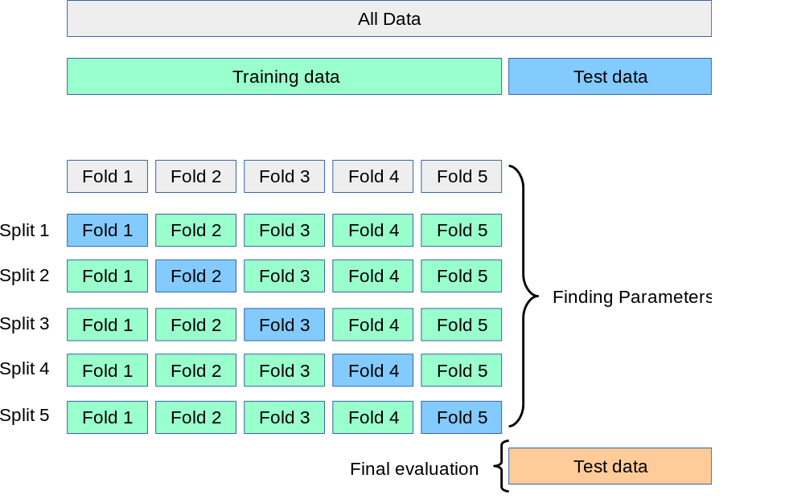
Fig 1.1 cross validation

2. SYSTEM ANALYSIS

2.1 Methodology
The machine learning system is built with 4 algorithms KNN, decision tree, naive bayes and random forest.

2.2 Data collection
Data is collected in a CSV format file for reading input.
This data consist of attributes like age, sex, bp,etc.

2.3 Software Development Life Cycle (Spiral Model)
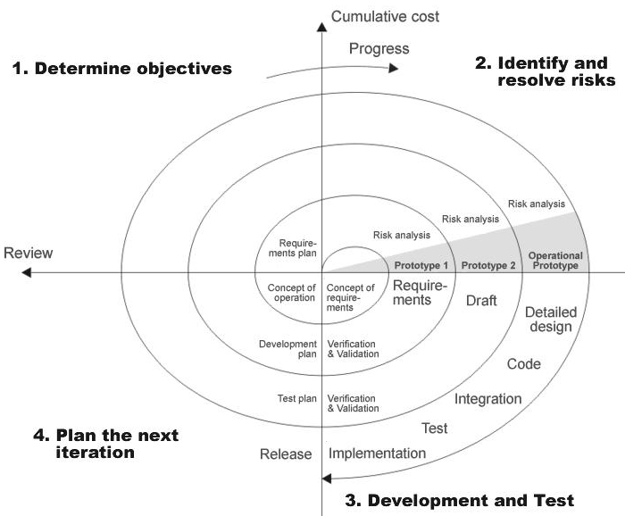

Fig 2.1 SDLC(Spiral model)

SDLC is nothing but Software Development Life Cycle. It is a standard which is used by software industry to develop good software.
Stages in SDLC:

- Requirement Gathering
- Analysis
- Designing
- Coding
- Testing
- Maintenance
Requirements Gathering stage:
The requirements gathering process takes as its input the goals identified in the high-level requirements section of the project plan. Each goal will be refined into a set of one or more requirements. These requirements define the major functions of the intended application, define operational data areas and reference data areas, and define the initial data entities. Major functions include critical processes to be managed, as well as mission critical inputs, outputs and reports. A user class hierarchy is developed and associated with these major functions, data areas, and data entities. Each of these definitions is termed a Requirement. Requirements are identified by unique requirement identifiers and, at minimum, contain a requirement title and textual description.
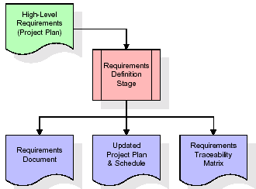
Fig 2.2 Requirements Gathering stage
These requirements are fully described in the primary deliverables for this stage the Requirements Document and the Requirements Traceability Matrix (RTM). The requirements document contains complete descriptions of each requirement, including diagrams and references to external documents as necessary. Note that detailed listings of database tables and fields are not included in the requirements document.
The title of each requirement is also placed into the first version of the RTM, along with the title of each goal from the project plan. The purpose of the RTM is to show that the product components developed during each stage of the software development lifecycle are formally connected to the components developed in prior stages.

In the requirements stage, the RTM consists of a list of high-level requirements, or goals, by title, with a listing of associated requirements for each goal, listed by requirement title. In this hierarchical listing, the RTM shows that each requirement developed during this stage is formally linked to a specific product goal. In this format, each requirement can be traced to a specific product goal, hence the term requirements traceability.
The outputs of the requirements definition stage include the requirements document, the RTM, and an updated project plan.
- Feasibility study is all about identification of problems in a project.
- No. of staff required to handle a project is represented as Team Formation, in this case only modules are individual tasks will be assigned to employees who are working for that project.
- Project Specifications are all about representing of various possible inputs submitting to the server and corresponding outputs along with reports maintained by administrator
Analysis Stage
The planning stage establishes a bird's eye view of the intended software product, and uses this to establish the basic project structure, evaluate feasibility and risks associated with the project, and describe appropriate management and technical approaches.
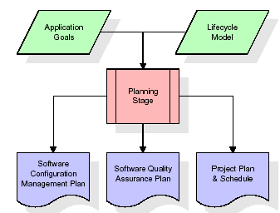
Fig 2.3 Analysis Stage
The most critical section of the project plan is a listing of high-level product requirements, also referred to as goals. All of the software product requirements to be developed during the requirements definition stage flow from one or more of these goals. The minimum information for each goal consists of a title and textual description, although additional information and references to external documents may be included. The outputs of the project planning stage are the configuration management plan, the quality assurance plan, and the project plan and schedule, with a detailed listing of scheduled activities for the upcoming Requirements stage, and high level estimates of effort for the out stages.
Designing Stage:
The design stage takes as its initial input the requirements identified in the approved requirements document. For each requirement, a set of one or more design elements will be produced as a result of interviews, workshops, and/or prototype efforts. Design elements describe the desired software features in detail, and generally include functional hierarchy diagrams, screen layout diagrams, tables of business rules, business process diagrams, pseudo code, and a complete entity-relationship diagram with a full data dictionary. These design elements are intended to describe the software in sufficient detail that skilled programmers may develop the software with minimal additional input.
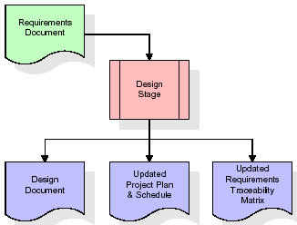
Fig. 2.4 Designing Stage
When the design document is finalized and accepted, the RTM is updated to show that each design element is formally associated with a specific requirement. The outputs of the design stage are the design document, an updated RTM, and an updated project plan.
Development (Coding) Stage
The development stage takes as its primary input the design elements described in the approved design document. For each design element, a set of one or more software artifacts will be produced. Software artifacts include but are not limited to menus, dialogs, data management forms, data reporting formats, and specialized procedures and functions. Appropriate test cases will be developed for each set of functionally related software artifacts, and an online help system will be developed to guide users in their interactions with the software.
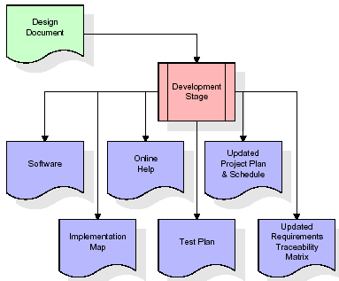
Fig 2.5 Development (Coding) Stage
The RTM will be updated to show that each developed artifact is linked to a specific design element, and that each developed artifact has one or more corresponding test case items. At this point, the RTM is in its final configuration. The outputs of the development stage include a fully functional set of software that satisfies the requirements and design elements previously documented, an online help system that describes the operation of the software, an implementation map that identifies the primary code entry points for all major system functions, a test plan that describes the test cases to be used to validate the correctness and completeness of the software, an updated RTM, and an updated project plan.
Integration & Test Stage
During the integration and test stage, the software artifacts, online help, and test data are migrated from the development environment to a separate test environment. At this point, all test cases are run to verify the correctness and completeness of the software. Successful execution of the test suite confirms a robust and complete migration capability. During this stage, reference data is finalized for production use and production users are identified and linked to their appropriate roles. The final reference data (or links to reference data source files) and production user list are compiled into the Production Initiation Plan.
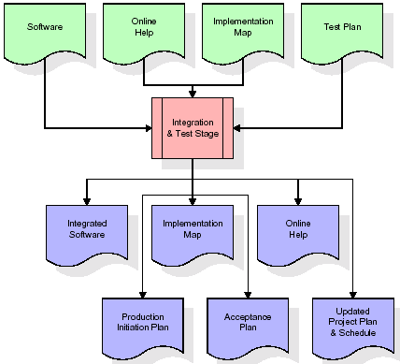
Fig 2.6 Integration & Test Stage
The outputs of the integration and test stage include an integrated set of software, an online help system, an implementation map, a production initiation plan that describes reference data and production users, an acceptance plan which contains the final suite of test cases, and an updated project plan.
Installation & Acceptance Test
During the installation and acceptance stage, the software artifacts, online help, and initial production data are loaded onto the production server. At this point, all test cases are run to verify the correctness and completeness of the software. Successful execution of the test suite is a prerequisite to acceptance of the software by the customer.
After customer personnel have verified that the initial production data load is correct and the test suite has been executed with satisfactory results, the customer formally accepts the delivery of the software.
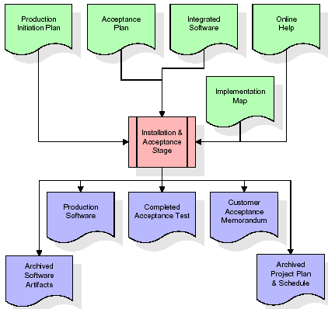
Fig 2.7 Installation & Acceptance Test
The primary outputs of the installation and acceptance stage include a production application, a completed acceptance test suite, and a memorandum of customer acceptance of the software. Finally, the PDR enters the last of the actual labor data into the project schedule and locks the project as a permanent project record. At this point the PDR "locks" the project by archiving all software items, the implementation map, the source code, and the documentation for future reference.
Maintenance

Outer rectangle represents maintenance of a project, Maintenance team will start with requirement study, understanding of documentation later employees will be assigned work and they will undergo training on that particular assigned category.
For this life cycle there is no end, it will be continued so on like an umbrella (no ending point to umbrella sticks).

2.4 Data Mining
There is a huge amount of data available in the Information Industry. This data is of no use until it is converted into useful information. It is necessary to analyze this huge amount of data and extract useful information from it. Extraction of information is not the only process we need to perform; data mining also involves other processes such as Data Cleaning, Data Integration, Data Transformation, Data Mining, Pattern Evaluation and Data Presentation. Once all these processes are over, we would be able to use this information in many applications such as Fraud Detection, Market Analysis, Production Control, Science Exploration, etc.
What is Data Mining?
Data Mining is defined as extracting information from huge sets of data. In other words, we can say that data mining is the procedure of mining knowledge from data. The information or knowledge extracted so can be used for any of the following applications:
Market Analysis
Fraud Detection
Customer Retention
Production Control
Science Exploration
Data Mining Applications
Data mining is highly useful in the following domains: Market Analysis and Management
Corporate Analysis
& Risk Management Fraud Detection
Apart from these, data mining can also be used in the areas of production control, customer retention, science exploration, sports, astrology, and Internet Web Surf-Aid

DATA MINING ON WHAT KIND OF DATA?
RELATIONAL DATABASES
A database system, also called a database management system (DBMS), consists of a collection of interrelated data, known as a database, and a set of software programs to manage and access the data A relational database is a collection of tables, each of which is assigned a unique name. Each table consists of a set of attributes (columns or fields) and usually stores a large set of tuples (records or rows)
Each tuple in a relational table represents an object identified by a unique key and described by a set of attribute values A semantic data model, such as an entity-relationship (ER) data model, is often constructed for relational databases. An ER data model represents the database as a set of entities and their relationships Relational data can be accessed by database queries written in a relational query language, such as SQL
DATA WAREHOUSES
A data warehouse is a repository of information collected from multiple sources, stored under a unified schema, and that usually resides at a single site Data warehouses are constructed via a process of data cleaning, data integration, data transformation, data loading, and periodic data refreshing
OBJECT-RELATIONAL DATABASES
Based on an object-relational data model Extends the relational model by providing a rich data type for handling complex objects and object orientation Objects that share a common set of properties can be grouped into an object class. Each object is an instance of its class. Object classes can be organized into class/subclass hierarchies
ADVANCED DATA AND INFORMATION SYSTEMS
With the progress of database technology, various kinds of advanced data and information systems have emerged and are undergoing development to address the requirements of new applications handling spatial/temporal data (such as maps) engineering design data (such as the design of buildings, system components, or integrated circuits) hypertext and multimedia data (including text, image, video, and audio data) time-related data (such as historical records or stock exchange data) stream data (such as video surveillance and sensor data, where data flow in and out like streams) the World Wide Web (a huge, widely distributed information repository made available by the Internet)
THE WORLD WIDE WEB
The World Wide Web and its associated distributed information services, such as Yahoo! and Google provide rich, worldwide, on-line information services, where data objects are linked together to facilitate interactive access Capturing user access patterns in such distributed information environments is called Web usage mining (or Weblog mining)
Database or data warehouse server responsible for fetching the relevant data, based on the user’s data mining request can be decouples/loose coupled/tightly coupled with the database layer
Knowledge base the domain knowledge that is used to guide the search or evaluate the interestingness of resulting patterns interestingness constraints or thresholds, metadata, concept hierarchies, etc.
Data mining engine this is essential to the data mining system and ideally consists of a set of functional modules for tasks such as characterization, association and correlation analysis, classification, prediction, cluster analysis, outlier analysis, and evolution analysis query languages (DMQL) based on mining primitives to access the data
Pattern evaluation module interacts with the data mining modules so as to focus the search toward interesting patterns may use interestingness thresholds to filter out discovered patterns may be integrated with the mining module
User interface communicates between users and the data mining system allows the user to interact with the system by specifying a data mining query or task, providing information to help focus the search, and performing exploratory data mining based on the intermediate data mining results allows the user to browse database and data warehouse schemas or data structures, evaluate mined patterns, and visualize the patterns in different forms

2.5 Algorithm implemented
K-Nearest Neighbour
The k-nearest neighbor algorithm is a pattern recognition model that can be used for classification as well as regression. Often abbreviated as k-NN, the k in k-nearest neighbor is a positive integer, which is typically small. In either classification or regression, the input will consist of the k closest training examples within a space.
We will focus on k-NN classification. In this method, the output is class membership. This will assign a new object to the class most common among its k nearest neighbors. In the case of k = 1, the object is assigned to the class of the single nearest neighbor.
When a new object is added to the space — in this case a green heart — we will want the machine learning algorithm to classify the heart to a certain class.
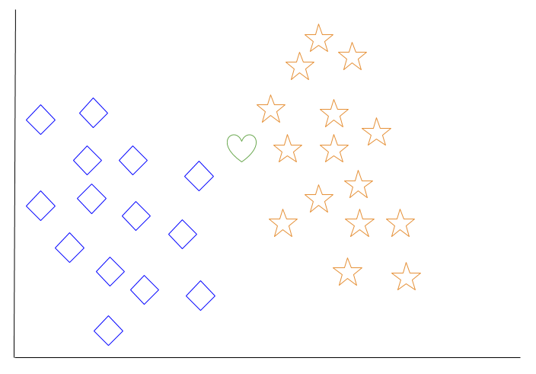
Fig. 2.8 knn example-1
When we choose k = 3, the algorithm will find the three nearest neighbors of the green heart in order to classify it to either the diamond class or the star class.
In our diagram, the three nearest neighbors of the green heart are one diamond and two stars. Therefore, the algorithm will classify the heart with the star class.
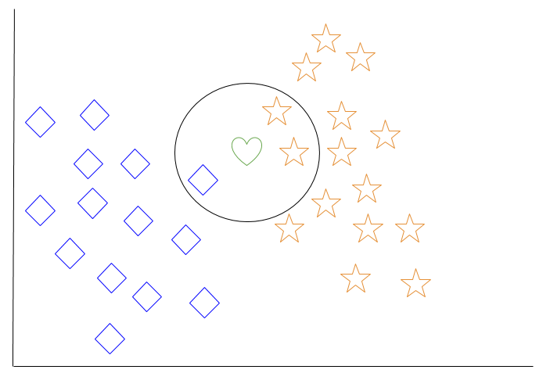
Fig. 2.9 knn example-2
Among the most basic of machine learning algorithms, k-nearest neighbor is considered to be a type of “lazy learning” as generalization beyond the training data does not occur until a query is made to the system.
Decision Tree
For general use, decision trees are employed to visually represent decisions and show or inform decision making. When working with machine learning and data mining, decision trees are used as a predictive model. These models map observations about data to conclusions about the data’s target value.
The goal of decision tree learning is to create a model that will predict the value of a target based on input variables.
In the predictive model, the data’s attributes that are determined through observation are represented by the branches, while the conclusions about the data’s target value are represented in the leaves.
When “learning” a tree, the source data is divided into subsets based on an attribute value test, which is repeated on each of the derived subsets recursively. Once the subset at a node has the equivalent value as its target value has, the recursion process will be complete.
Let’s look at an example of various conditions that can determine whether or not someone should go fishing. This includes weather conditions as well as barometric pressure conditions.
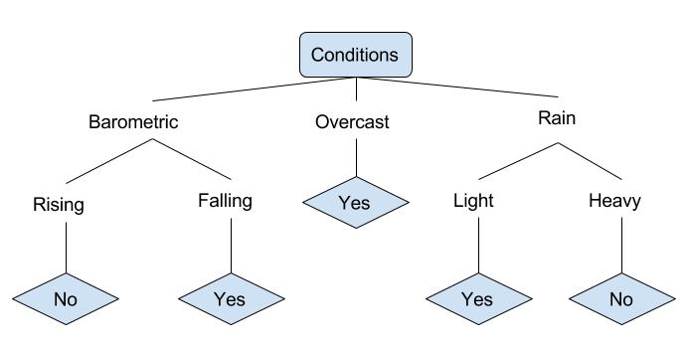
Fig. 2.10 decision tree example
In the simplified decision tree above, an example is classified by sorting it through the tree to the appropriate leaf node. This then returns the classification associated with the particular leaf, which in this case is either a Yes or a No. The tree classifies a day’s conditions based on whether or not it is suitable for going fishing.
A true classification tree data set would have a lot more features than what is outlined above, but relationships should be straightforward to determine. When working with decision tree learning, several determinations need to be made, including what features to choose, what conditions to use for splitting, and understanding when the decision tree has reached a clear ending.
Naive Bayes
It is a classification technique based on Bayes’ Theorem with an assumption of independence among predictors. In simple terms, a Naive Bayes classifier assumes that the presence of a particular feature in a class is unrelated to the presence of any other feature.
For example, a fruit may be considered to be an apple if it is red, round, and about 3 inches in diameter. Even if these features depend on each other or upon the existence of the other features, all of these properties independently contribute to the probability that this fruit is an apple and that is why it is known as ‘Naive’.
Naive Bayes model is easy to build and particularly useful for very large data sets. Along with simplicity, Naive Bayes is known to outperform even highly sophisticated classification methods.
Bayes theorem provides a way of calculating posterior probability P(c|x) from P(c), P(x) and P(x|c). Look at the equation below:
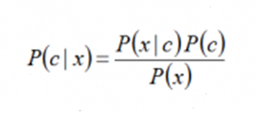
Above,
P(c|x) is the posterior probability of class (c, target) given predictor (x, attributes).
P(c) is the prior probability of class.
P(x|c) is the likelihood which is the probability of predictor given class.
P(x) is the prior probability of predictor.
Gaussian Naive Bayes classifier
In Gaussian Naive Bayes, continuous values associated with each feature are assumed to be distributed according to a Gaussian distribution. A Gaussian distribution is also called Normal distribution. When plotted, it gives a bell shaped curve which is symmetric about the mean of the feature values as shown below:
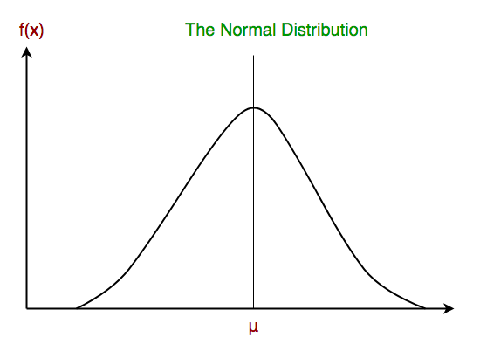
Fig 2.11 GNB
The likelihood of the features is assumed to be Gaussian, hence, conditional probability is given by:
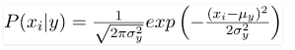
Now, we look at an implementation of Gaussian Naive Bayes classifier using scikit-learn.

Random Forest
Random Forest is a popular machine learning algorithm that belongs to the supervised learning technique. It can be used for both Classification and Regression problems in ML. It is based on the concept of ensemble learning, which is a process of combining multiple classifiers to solve a complex problem and to improve the performance of the model.
As the name suggests, "Random Forest is a classifier that contains a number of decision trees on various subsets of the given dataset and takes the average to improve the predictive accuracy of that dataset." Instead of relying on one decision tree, the random forest takes the prediction from each tree and based on the majority votes of predictions, and it predicts the final output.
The greater number of trees in the forest leads to higher accuracy and prevents the problem of overfitting.
The below diagram explains the working of the Random Forest algorithm:
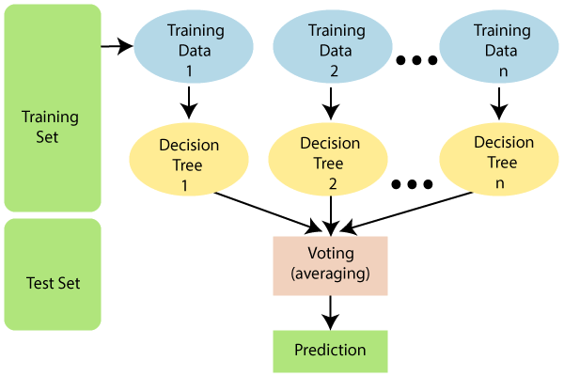
Fig. 2.12 Random forest
Random Forest works in two-phase first is to create the random forest by combining N decision tree, and second is to make predictions for each tree created in the first phase.
The Working process can be explained in the below steps and diagram:
Step-1: Select random K data points from the training set.
Step-2: Build the decision trees associated with the selected data points (Subsets).
Step-3: Choose the number N for decision trees that you want to build.
Step-4: Repeat Step 1 & 2.
Step-5: For new data points, find the predictions of each decision tree, and assign the new data points to the category that wins the majority votes.
The working of the algorithm can be better understood by the below example:
For Example, Suppose there is a dataset that contains multiple fruit images. So, this dataset is given to the Random forest classifier. The dataset is divided into subsets and given to each decision tree. During the training phase, each decision tree produces a prediction result, and when a new data point occurs, then based on the majority of results, the Random Forest classifier predicts the final decision. Consider the below image:
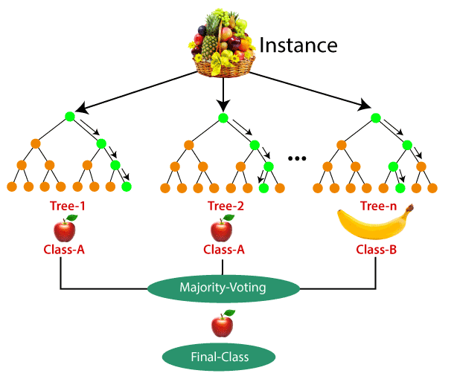
Fig. 2.13 Random forest example

2.6 System Architecture
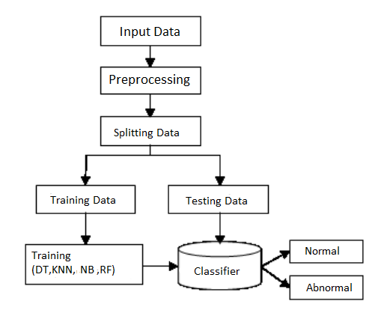
Fig. 2.14 system architecture
Input Data
First the data set is read for further process. This source is a comma separated file (CSV).
Preprocessing
The database contains NaN values. The NaN values cannot process by the programming hence these values need to convert into numerical values. In this approach mean of the column is calculated and NaN values are replaced by the mean.
Splitting Data
The whole database is split into training and testing database. The 80% data is taken for training while remaining 20% data is used for testing.
Training Data
This data is used to train the model
Testing Data
This data is used to test the trained model for checking accuracy of output.
Training
The model is trained for prediction purpose.
Classification
The training data is trained by using four different machine learning algorithms i.e. Decision Tree, KNN, Random forest and. Each algorithm is explained in detail.

FEASIBILITY STUDY
The feasibility of the project is analyzed in this phase and business proposal is put forth with a very general plan for the project and some cost estimates. During system analysis the feasibility study of the proposed system is to be carried out. This is to ensure that the proposed system is not a burden to the company. For feasibility analysis, some understanding of the major requirements for the system is essential. Three key considerations involved in the feasibility analysis are,
- Economical Feasibility
- Technical Feasibility
- Social Feasibility

3.1 Economical Feasibility
This study is carried out to check the economic impact that the system will have on the organization. The amount of fund that the company can pour into the research and development of the system is limited. The expenditures must be justified. Thus the developed system as well within the budget and this was achieved because most of the technologies used are freely available. Only the customized products had to be purchased.

3.2 Technical Feasibility
This study is carried out to check the technical feasibility, that is, the technical requirements of the system. Any system developed must not have a high demand on the available technical resources. This will lead to high demands on the available technical resources. This will lead to high demands being placed on the client. The developed system must have a modest requirement, as only minimal or null changes are required for implementing this system.

3.3 Social Feasibility
The aspect of study is to check the level of acceptance of the system by the user. This includes the process of training the user to use the system efficiently. The user must not feel threatened by the system, instead must accept it as a necessity. The level of acceptance by the users solely depends on the methods that are employed to educate the user about the system and to make him familiar with it. His level of confidence must be raised so that he is also able to make some constructive criticism, which is welcomed, as he is the final user of the system.

4. REQUIREMENT SPECIFICATIONS

4.1 Hardware Requirements
Processor | : Dual core and above
Speed | : 1.1GHz and above
RAM | : 2GB and above
Storage device | : 20 GB and above

4.2 Software Requirements
OS | : Windows 10
IDE | : Anaconda (Jupiter notebook)
Technology | : Python
Data file type | : CVS

4.2.1 Introduction to Python
Python is a general-purpose interpreted, interactive, object-oriented, and high-level programming language. An interpreted language, Python has a design philosophy that emphasizes code readability (notably using whitespace indentation to delimit code blocks rather than curly brackets or keywords), and a syntax that allows programmers to express concepts in fewer lines of code than might be used in languages such as C++or Java. It provides constructs that enable clear programming on both small and large scales. Python interpreters are available for many operating systems. CPython, the reference implementation of Python, is open source software and has a community-based development model, as do nearly all of its variant implementations. CPython is managed by the non-profit Python Software Foundation. Python features a dynamic type system and automatic memory management. It supports multiple programming paradigms, including object-oriented, imperative, functional and procedural, and has a large and comprehensive standard library.
Python is a multi-paradigm programming language. Object-oriented programming and structured programming are fully supported, and many of its features support functional programming and aspect-oriented programming (including by meta programming and meta objects (magic methods)). Many other paradigms are supported via extensions, including design by contract and logic programming.
Python uses dynamic typing, and a combination of reference counting and a cycle-detecting garbage collector for memory management. It also features dynamic name resolution(late binding), which binds method and variable names during program execution.
Python's design offers some support for functional programming in the Lisp tradition. It has filter(), map(), and reduce() functions; list comprehensions, dictionaries, and sets; and generator expressions. The standard library has two modules (itertools and functools) that implement functional tools borrowed from Haskell and Standard ML.
The language's core philosophy is summarized in the document The Zen of Python , which includes aphorisms such as:
- Beautiful is better than ugly
- Explicit is better than implicit
- Simple is better than complex
- Complex is better than complicated
- Readability counts
Rather than having all of its functionality built into its core, Python was designed to be highly extensible. This compact modularity has made it particularly popular as a means of adding programmable interfaces to existing applications. Van Rossum's vision of a small core language with a large standard library and easily extensible interpreter stemmed from his frustrations with ABC, which espoused the opposite approach.
While offering choice in coding methodology, the Python philosophy rejects exuberant syntax (such as that of Perl) in favor of a simpler, less-cluttered grammar. As Alex Martelli put it: "To describe something as 'clever' is not considered a compliment in the Python culture." Python's philosophy rejects the Perl "there is more than one way to do it" approach to language design in favour of "there should be one—and preferably only one—obvious way to do it".
Python's developers strive to avoid premature optimization, and reject patches to non-critical parts of the CPython reference implementation that would offer marginal increases in speed at the cost of clarity. When speed is important, a Python programmer can move time-critical functions to extension modules written in languages such as C, or use PyPy, a just-in-time compiler. Cython is also available, which translates a Python script into C and makes direct C-level API calls into the Python interpreter.
An important goal of Python's developers is keeping it fun to use. This is reflected in the language's name—a tribute to the British comedy group Monty Python—and in occasionally playful approaches to tutorials and reference materials, such as examples that refer to spam and eggs (from a famous Monty Python sketch) instead of the standard foo and bar.
A common neologism in the Python community is pythonic, which can have a wide range of meanings related to program style. To say that code is pythonic is to say that it uses Python idioms well, that it is natural or shows fluency in the language, that it conforms with Python's minimalist philosophy and emphasis on readability. In contrast, code that is difficult to understand or reads like a rough transcription from another programming language is called unpythonic.Users and admirers of Python, especially those considered knowledgeable or experienced, are often referred to as Pythonists, Pythonistas, and Pythoneers.

4.2.2 Modules used

numpy
NumPy is a general-purpose array-processing package. It provides a high-performance multidimensional array object, and tools for working with these arrays.
It is the fundamental package for scientific computing with Python. It contains various features including these important ones:
- A powerful N-dimensional array object
- Useful linear algebra, Fourier transform, and random number capabilities

Besides its obvious scientific uses, NumPy can also be used as an efficient multi-dimensional container of generic data.
Arbitrary data-types can be defined using Numpy which allows NumPy to seamlessly and speedily integrate with a wide variety of databases.

pandas
Pandas is a high-level data manipulation tool developed by Wes McKinney. It is built on the Numpy package and its key data structure is called the DataFrame. DataFrames allow you to store and manipulate tabular data in rows of observations and columns of variables.

matplotlib
Matplotlib is an amazing visualization library in Python for 2D plots of arrays. Matplotlib is a multi-platform data visualization library built on NumPy arrays and designed to work with the broader SciPy stack. It was introduced by John Hunter in the year 2002.
One of the greatest benefits of visualization is that it allows us visual access to huge amounts of data in easily digestible visuals. Matplotlib consists of several plots like line, bar, scatter, histogram etc.

Seaborn
Seaborn is a Python data visualization library based on matplotlib. It provides a high-level interface for drawing attractive and informative statistical graphics.

sklearn
It is a free machine learning library for Python. It features various algorithms like support vector machine, random forests, and k-neighbours, and it also supports Python numerical and scientific libraries like NumPy and SciPy.

4.2.3 Anaconda
Anaconda is a free and open-source distribution of the Python and R programming languages for scientific computing (data science, machine learning applications, large-scale data processing, predictive analytics, etc.), that aims to simplify package management and deployment. The distribution includes data-science packages suitable for Windows, Linux, and macOS. It is developed and maintained by Anaconda, Inc., As an Anaconda, Inc. product, it is also known as Anaconda Distribution or Anaconda Individual Edition, while other products from the company are Anaconda Team Edition and Anaconda Enterprise Edition, which are both not free.
Package versions in Anaconda are managed by the package management system conda. This package manager was spun out as a separate open-source package as it ended up being useful on its own and for other things than Python. There is also a small, bootstrap version of Anaconda called Miniconda, which includes only conda, Python, the packages they depend on, and a small number of other packages.

Anaconda Navigator
Anaconda Navigator is a desktop graphical user interface (GUI) included in Anaconda distribution that allows users to launch applications and manage conda packages, environments and channels without using command-line commands. Navigator can search for packages on Anaconda Cloud or in a local Anaconda Repository, install them in an environment, run the packages and update them. It is available for Windows, macOS and Linux.
The following applications are available by default in Navigator:
- JupyterLab
- Jupyter Notebook
- Qt Console
- Spyder
- Glueviz
- Orange 3
- RStudio
- Visual Studio Code

5. SYSTEM DESIGN

5.1 Introduction
Systems design is the process or art of defining the architecture, components, modules, interfaces, and data for a system to satisfy specified requirements. One could see it as the application of systems theory to product development. There is some overlap and synergy with the disciplines of systems analysis, systems architecture and systems engineering.

5.2 Data Flow Diagram
- The DFD is also called as bubble chart. It is a simple graphical formalism that can be used to represent a system in terms of input data to the system, various processing carried out on this data, and the output data is generated by this system.
- The data flow diagram (DFD) is one of the most important modeling tools. It is used to model the system components. These components are the system process, the data used by the process, an external entity that interacts with the system and the information flows in the system.
- DFD shows how the information moves through the system and how it is modified by a series of transformations. It is a graphical technique that depicts information flow and the transformations that are applied as data moves from input to output.
- DFD is also known as bubble chart. A DFD may be used to represent a system at any level of abstraction. DFD may be partitioned into levels that represent increasing information flow and functional detail.

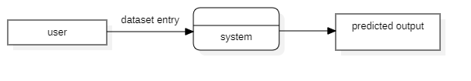
Fig. 5.1 Data flow diagram

5.3 UML Diagrams

Unified Modeling Language

The Unified Modeling Language allows the software engineer to express an analysis model using the modeling notation that is governed by a set of syntactic semantic and pragmatic rules.

A UML system is represented using five different views that describe the system from distinctly different perspective. Each view is defined by a set of diagrams, which is as follows.
  - User Model View
    - This view represents the system from the user’s perspective.
    - The analysis representation describes a usage scenario from the end-user’s perspective.

  - Structural model view
    - In this model the data and functionality are arrived from inside the system.
    - This model view models the static structures.

- Behavioural Model View
It represents the dynamic of behavioural as parts of the system, depicting the interactions of collection between various structural elements described in the user model and structural model view.
- Implementation Model View
In this the structural and behavioral as parts of the system are represented as they are to be built.

- Environmental Model View
In this the structural and behavioral aspects of the environment in which the system is to be implemented are represented.

UML is specifically constructed through two different domains they are:
- UML Analysis modeling, this focuses on the user model and structural model views of the system.
- UML design modeling, which focuses on the behavioral modeling, implementation modeling and environmental model views.

5.3.1 Use Case diagram
A use case diagram in the Unified Modeling Language (UML) is a type of behavioral diagram defined by and created from a Use-case analysis. Its purpose is to present a graphical overview of the functionality provided by a system in terms of actors, their goals (represented as use cases), and any dependencies between those use cases. The main purpose of a use case diagram is to show what system functions are performed for which actor. Roles of the actors in the system can be depicted.

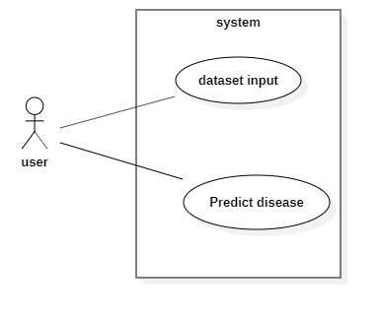
Fig 5.2 usecase diagram

5.3.2 Class Diagram
In software engineering, a class diagram in the Unified Modeling Language (UML) is a type of static structure diagram that describes the structure of a system by showing the system's classes, their attributes, operations (or methods), and the relationships among the classes. It explains which class contains information.

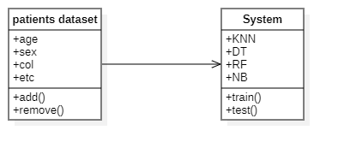

Fig 5.3 Class Diagram

5.3.3 Sequence Diagram
A sequence diagram in Unified Modeling Language (UML) is a kind of interaction diagram that shows how processes operate with one another and in what order. It is a construct of a Message Sequence Chart. Sequence diagrams are sometimes called event diagrams, event scenarios, and timing diagrams.

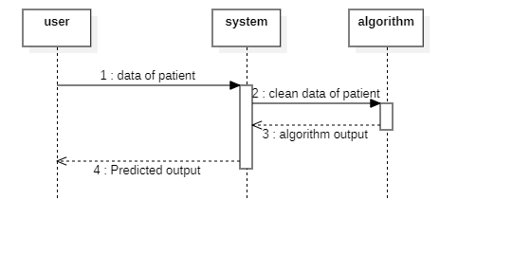
Fig 5.4 Sequence Diagram

5.3.4 Activity Diagram
Activity diagrams are graphical representations of workflows of stepwise activities and actions with support for choice, iteration and concurrency. In the Unified Modeling Language, activity diagrams can be used to describe the business and operational step-by-step workflows of components in a system. An activity diagram shows the overall flow of control.

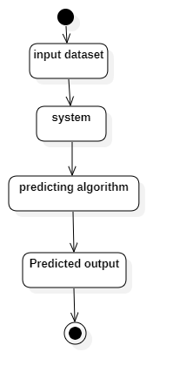
Fig 5.5 Activity Diagram

6. IMPLEMENTAION CODING
Data input
hd=pd.read_csv('heart.csv')
hd.head()
Data visualization
import matplotlib.pyplot as plt #For visualization
from matplotlib import rcParams #add styling to the plots
from matplotlib.cm import rainbow #for colors
import seaborn as sns
rcParams['figure.figsize'] = 20, 14
hd.hist()
Data preprocessing
from sklearn.preprocessing import StandardScaler
scaler = StandardScaler().fit(x)
x=scaler.transform(x)
Training and Testing
from sklearn.tree import DecisionTreeClassifier
DT=DecisionTreeClassifier()
DT.fit(x_train,y_train)
DT.score(x_test,y_test)
DT.score(x_train,y_train)
DT.score(x,y)
Predicting
x=[[41,0,1,130,204,0,0,172,0,1.4,2,0,2]]
x=scaler.transform(x)
RF.predict(x)

7. SYSTEM TEST

7.1 Introduction
The purpose of testing is to discover errors. Testing is the process of trying to discover every conceivable fault or weakness in a work product. It provides a way to check the functionality of components, sub assemblies, assemblies and/or a finished product It is the process of exercising software with the intent of ensuring that the Software system meets its requirements and user expectations and does not fail in an unacceptable manner. There are various types of test. Each test type addresses a specific testing requirement.
TYPES OF TESTS
Unit testing
Unit testing involves the design of test cases that validate that the internal program logic is functioning properly, and that program inputs produce valid outputs. All decision branches and internal code flow should be validated. It is the testing of individual software units of the application .it is done after the completion of an individual unit before integration. This is a structural testing, that relies on knowledge of its construction and is invasive. Unit tests perform basic tests at component level and test a specific business process, application, and/or system configuration. Unit tests ensure that each unique path of a business process performs accurately to the documented specifications and contains clearly defined inputs and expected results.
Integration Testing
Integration tests are designed to test integrated software components to determine if they actually run as one program. Testing is event driven and is more concerned with the basic outcome of screens or fields. Integration tests demonstrate that although the components were individually satisfaction, as shown by successfully unit testing, the combination of components is correct and consistent. Integration testing is specifically aimed at exposing the problems that arise from the combination of components.

Functional test
Functional tests provide systematic demonstrations that functions tested are available as specified by the business and technical requirements, system documentation, and user manuals.
Functional testing is centered on the following items:
Valid Input : identified classes of valid input must be accepted.
Invalid Input : identified classes of invalid input must be rejected.
Functions : identified functions must be exercised.
Output : identified classes of application outputs must be exercised.
Systems/Procedures : interfacing systems or procedures must be invoked.
Organization and preparation of functional tests is focused on requirements, key functions, or special test cases. In addition, systematic coverage pertaining to identify Business process flows; data fields, predefined processes, and successive processes must be considered for testing. Before functional testing is complete, additional tests are identified and the effective value of current tests is determined.

System Test
System testing ensures that the entire integrated software system meets requirements. It tests a configuration to ensure known and predictable results. An example of system testing is the configuration oriented system integration test. System testing is based on process descriptions and flows, emphasizing pre-driven process links and integration points.

White Box Testing
White Box Testing is a testing in which in which the software tester has knowledge of the inner workings, structure and language of the software, or at least its purpose. It is purpose. It is used to test areas that cannot be reached from a black box level.

Black Box Testing
Black Box Testing is testing the software without any knowledge of the inner workings, structure or language of the module being tested. Black box tests, as most other kinds of tests, must be written from a definitive source document, such as specification or requirements document, such as specification or requirements document. It is a testing in which the software under test is treated, as a black box .you cannot “see” into it. The test provides inputs and responds to outputs without considering how the software works.

Unit Testing
Unit testing is usually conducted as part of a combined code and unit test phase of the software lifecycle, although it is not uncommon for coding and unit testing to be conducted as two distinct phases.

7.2 Test strategy and approach
Field testing will be performed manually and functional tests will be written in detail.
Test objectives
- All field entries must work properly.
- Pages must be activated from the identified link.
- The entry screen, messages and responses must not be delayed.
Features to be tested
- Verify that the entries are of the correct format
- No duplicate entries should be allowed
- All links should take the user to the correct page.
Integration Testing
Software integration testing is the incremental integration testing of two or more integrated software components on a single platform to produce failures caused by interface defects.
The task of the integration test is to check that components or software applications, e.g. components in a software system or – one step up – software applications at the company level – interact without error.

Acceptance Testing
User Acceptance Testing is a critical phase of any project and requires significant participation by the end user. It also ensures that the system meets the functional requirements.
Test Results
All the test cases mentioned above passed successfully. No defects encountered.

8. OUTPUT SCREENS
Dataset
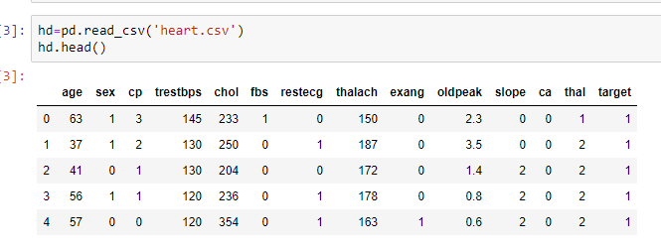
Screenshot 9.1 Dataset
Data visualization
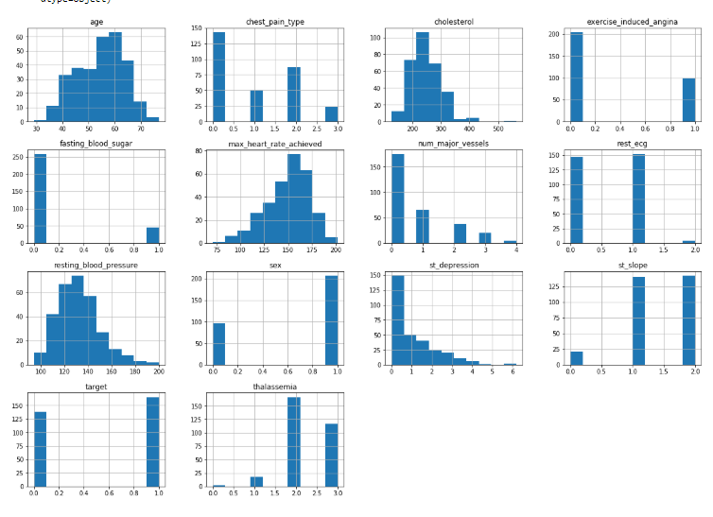
Screenshot 9.2 Data visualization
Data preprocessing
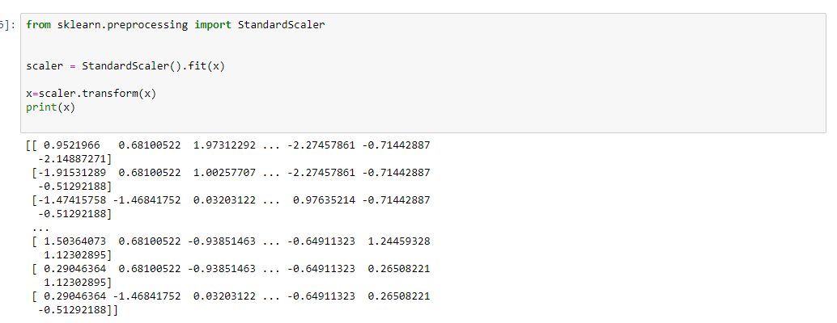
Screenshot 9.3 Data preprocessing
Training and Testing
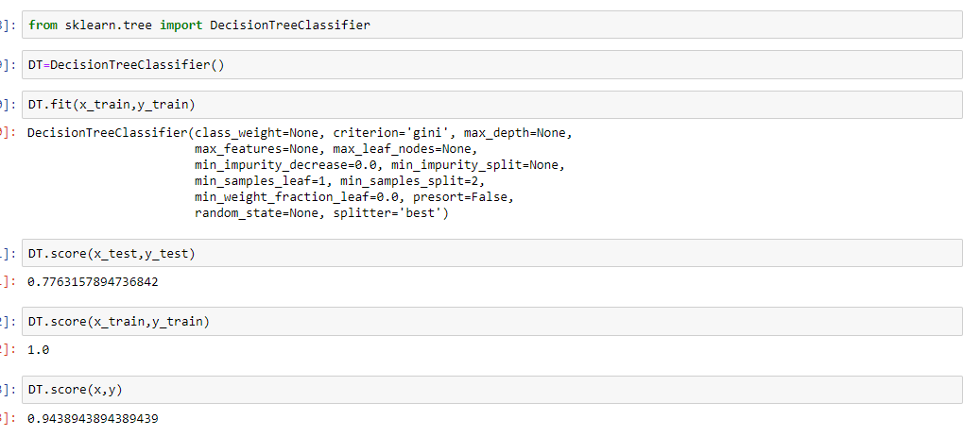
Screenshot 9.4 Training and testing
Predicting
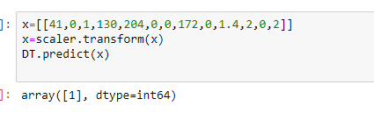
Screenshot 9.5 predicting

9. CONCLUSION
This work will be useful in identifying the possible patients who may suffer from heart disease in the next 10 years. This may help in taking preventive measures and hence try to avoid the possibility of heart disease for the patient. So when a patient is predicted as positive for heart disease, then the medical data for the patient can be closely analysed by the doctors.

10. BIBLIOGRAPHY
Numpy
https://numpy.org/doc/
pandas
https://pandas.pydata.org/docs/
matplotlib
https://matplotlib.org/3.2.1/contents.html
sklearn(scikit - learn)
https://scikit-learn.org/stable/user_guide.html

11. REFRENCES
P .K. Anooj, ―Clinical decision support system: Risk level prediction of heart disease using weighted fuzzy rulesǁ; Journal of King Saud University – Computer and Information Sciences (2012) 24, 27–40. Computer Science & Information Technology (CS & IT) 59
Nidhi Bhatla, Kiran Jyoti”An Analysis of Heart Disease Prediction using Different Data Mining Techniques”.International Journal of Engineering Research & Technology
Jyoti Soni Ujma Ansari Dipesh Sharma, Sunita Soni. “Predictive Data Mining for Medical Diagnosis: An Overview of Heart Disease Prediction”.
Chaitrali S. Dangare Sulabha S. Apte, Improved Study of Heart Disease Prediction System using Data Mining Classification Techniques” International Journal of Computer Applications (0975 – 888)
Dane Bertram, Amy Voida, Saul Greenberg, Robert Walker, “Communication, Collaboration, and Bugs: The Social Nature of Issue Tracking in Small, Collocated Teams”.
M. Anbarasi, E. Anupriya, N.Ch.S.N.Iyengar, ―Enhanced Prediction of Heart Disease with Feature Subset Selection using Genetic Algorithmǁ; International Journal of Engineering Science and Technology, Vol. 2(10), 2010.
Erickson, T., Smith, D., Kellogg, W., Laff, M., Richards, J and Bradner, E. Socially translucent conversations: Social proxies, persistent conversation, and the design of “Babble.”Proc. ACM CHI (1999), 72–79.
Hollan, J., Hutchins, E. and Kirsh, D. Distributed cognition: Toward a new foundation for human computer interaction research. ACM TOCHI, 7(2),(2000), 174–
Shantakumar B.Patil, Y.S.Kumaraswamy, ―Intelligent and Effective Heart Attack Prediction System Using Data Mining and Artificial Neural Networkǁ; European Journal of Scientific Research, ISSN 1450-216X Vol.31 No.4, 2009.
Statlog database: http://archive.ics.uci.edu/ml/machinelearning- databases/statlog/heart

